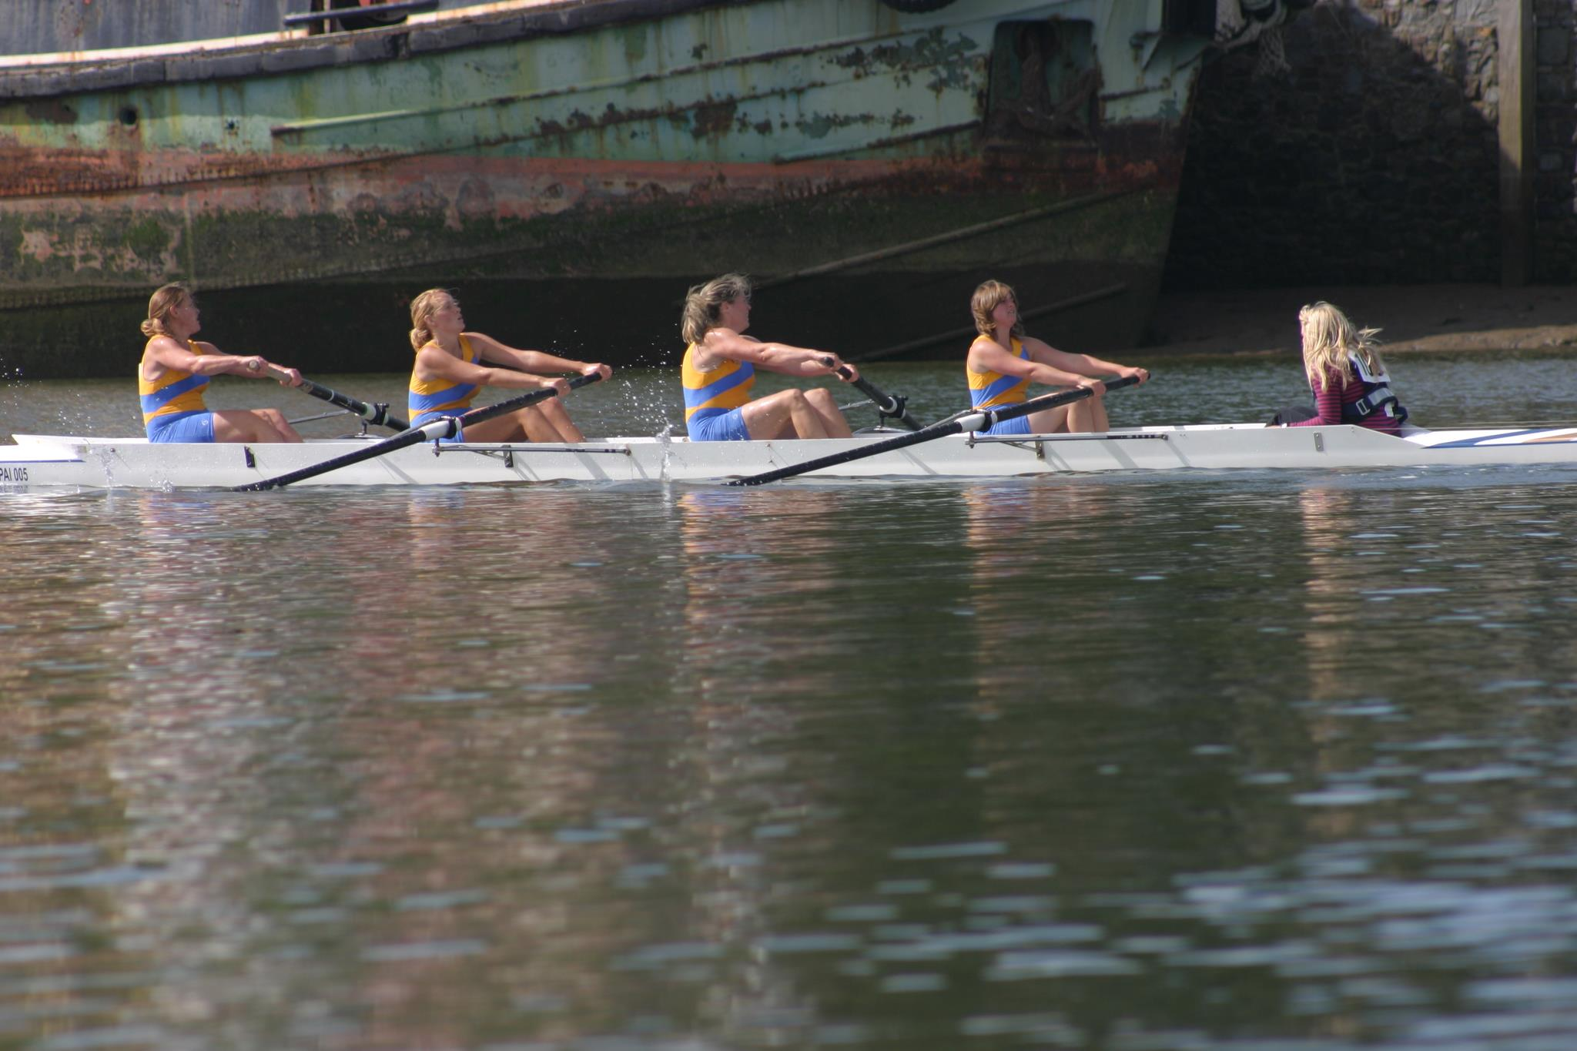

Paignton ARC Annual Regatta

Saturday 10th August

1000m course from Preston Slipway to The Shoreline Restaurant

Raced under WEARA Rules of Racing

Races for Men’s, Women’s and Mixed crews in the following classes:

Coxed Fours: Sen A, Sen B, Sen C, Novice, J18 and Masters

Coxed Quads: Sen A, Sen B, Sen C, Novice, J18, J16, J14, J12 and Masters

Doubles and Pairs: Sen A, Sen B, Sen C, Novice and Masters

Singles: Sen A, Sen B, Sen C, Novice, J18, J16, J14, J12 and Masters

Entries close Saturday 27th July at midnight.

The draw will take place of Sunday the 28th of July at 6pm at Paignton Amateur Rowing Club

Senior races £4.50 per seat / Junior Races £4 per seat for all WEARA Clubs. Non WEARA Clubs £6 per seat.

Please send entries to Rob Harris:

Fig Tree Barn, Fluder Hill, Kingskerswell, Newton Abbot, Devon, TQ12 4SX

Or email to skiffcaptain@paigntonarc.co.uk

Mobile: 07868 309715

Food and refreshments will be available on the day

Races likely to start at 9.30am due to the decreasing tide from 8.18am.